Solution Design Document Transportation Management System
April 06, 2023




19520 Jamboree Road #110 Irvine, CA 92612
949-241-8600
synoptek.com

Contents
Contents 1
Section 1: Version history 2
Section 2: Proposed Architecture 3
2.1 Technology Identification and Recommendations 3
2.2 Web Technology Stack 4
2.2.1 Responsive Web Frontend (Angular 15) 4
2.2.2 Web Backend (.Net 6, Java) 4
2.3 Application Components 5
2.3.1 Azure Kubernetes Service (AKS) 5
2.3.2 Azure SQL Database 5
2.3.3 Azure Container Registry (ACR) 5
2.3.4 Azure Key Vault 5
2.3.5 Azure Redis Cache 6
2.3.6 Azure Blob Storage 6
2.3.7 Front Door 6
2.3.8 Azure Function App 6
2.3.9 Queue Azure Service Bus / RabbitMQ 6
2.3.10 Elasticsearch (Elastic Cloud) for Azure 6
2.3.11 Azure Application Insights 6
2.3.12 Azure SignalR Service 6
2.3.13 MongoDB 7
2.3.14 Azure DNS 7
2.3.15 Azure DevOps Server 7
2.4 Third Party Integration 8
2.5 Authentication Mechanism 8
2.6 Browser Support 8
2.7 Performance Benchmarks 8
Section 3: Release Deployment Architecture 8

Version history

VERSION | DATE | AUTHOR | CHANGES
1.0 | April 06, 2023 | Rachana Thakkar | Initial Draft
1.1.1
1.1.2
1.2
1.2.1

Proposed Architecture
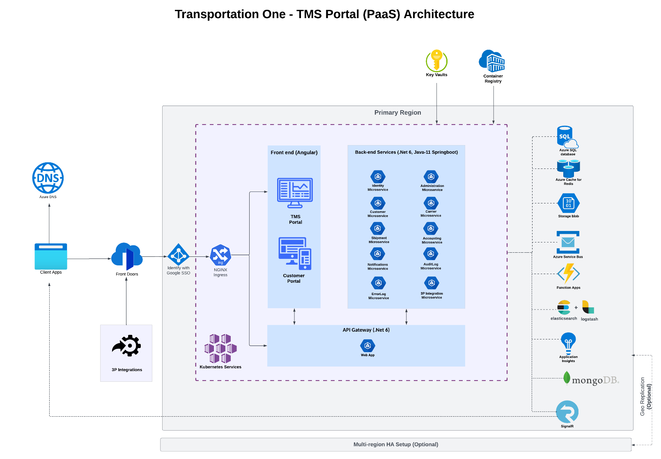

Technology Identification and Recommendations

Web Technology Stack
Web Backend | Microservice Architecture - .Net 6, Java 11 Springboot
Responsive Web Frontend | Angular 15
API Gateway | .Net 6
Application Components
Database | Azure SQL Database / Azure SQL Managed Instance
Application Hosting | Azure Kubernetes Service
Docker Container Images Storage | Azure Container Registry
Secure Secret Store | Azure Key Vault
Session Driver / Persistent Storage | Azure Redis Cache
Document Storage | Azure Blob Storage
WAF/CDN | Azure Front Door
Search Engine | Elasticsearch (Elastic Cloud) for Azure
Backend Jobs | Azure Function
Message Queue | Azure Service Bus / RabbitMQ
Real-time web functionality | Self-hosted SignalR / Azure SignalR Service
NoSQL Database (Logs) | MongoDB
Monitoring Tool (APM) | Azure Application Insights
Version Control, Sprint Planning and Tracking and Automated Deployment (CI/CD) | Azure DevOps Service

Web Technology Stack

Web Frontend (Angular 15)
Below web applications will be developed using Angular 15 client framework.
- TMS Portal – will be accessed by Transportation One Users, TMS Portal will allow users to manage shipments, customers, and carriers under one application.
- Customer Portal – will be accessed by Customers where customers are able to view shipment information including shipment details, tracking information, status, and documents associated with it.

API Gateway (.Net 6)
In this architecture an API Gateway will serve as a client’s entry point. The single point of contact from the client which, in turn, returns responses from underlying microservices and sometimes an aggregated response from multiple underlying microservices.
Features of API Gateway:
- Act as a Reverse proxy
- Handles Authentication and authorization.
- Aggregates the data.
- Error handling
- Response caching
- Transforms the requests and responses.
- Logging and tracing

Web Backend (Microservice Architecture - .Net 6, Java-11 Springboot)
Transportation One web application backend will be developed using .Net 6, Java framework and microservice architectural pattern will be followed.
- Advantage of microservice architecture
  - Loosely coupled.
  - Isolation
  - Independently Scalable
  - Unit testable
  - Independently deployable
  - Easy monitoring and tracking of services.
  - Easy maintenance

Below microservices (Rest APIs) will be developed for different Transportation One modules and common features.
- Module specific microservice:
  - Identity Service
  - Administration Service
  - Customer Service
  - Carrier Service
  - Shipment Service
  - Accounting Service

- Features specific microservice:
  - Notification Service (Email, SMS)
  - Log Service
  - Integration Service

Application Components
This architecture uses the following components:

Azure Kubernetes Service (AKS)
Transportation web front end and back end microservices will be containerized using Docker and will be deployed to Azure Kubernetes cluster. AKS autoscaling capabilities will be used to scale the application instance as needed in AKS cluster.
Azure Kubernetes Service (AKS) is a managed container orchestration service, based on the opensource Kubernetes system Deploy and manage containerized applications more easily with a fully managed Kubernetes service.
Synoptek recommends using Azure Kubernetes Service (AKS) to deploy and manage the Transportation One web applications to the cloud due to the features below of AKS.

Features of Azure Kubernetes Service
- Integrated logging and monitoring
- Cluster node and pod scaling
- Cluster node upgrades
- Storage volume support
- Virtual networks and ingress
- Ingress with HTTP application routing

Azure SQL Database
Azure SQL Database Service will be used as a Relational Database for Transportation One web application.
Azure SQL Database is a fully managed platform as a service (PaaS) database engine that handles most of the database management functions such as upgrading, patching, backups, and monitoring without user involvement. Azure SQL Database is always running on the latest stable version of the SQL Server database engine.

Azure Container Registry (ACR)
Azure Container Registry will be used to store private Docker images of application components, which will be deployed to the AKS cluster.

Azure Key Vault
Azure Key Vault will be used for storing application secrets like database connection string, other app configurations, third-party access details etc.

Azure Redis Cache
Azure Cache for Redis is a fully managed, in-memory cache that enables high-performance and scalable architectures. In Transportation One web app Azure Redis Cache service will be used for storing user session and semi-static data like application master data.
Features of Azure Redis Cache
- Efficiently store session data
- Speed up applications with a distributed cache.
- Improve application throughput and latency.
- Communicate between services as a message broker.
- Redis as a fully managed service

Azure Blob Storage
Azure blob storage can be used to store and access unstructured audio, video, images etc. In Transportation One web app Azure Blob Storage will be used to store and access application documents of different modules.

Front Door
In this architecture, Front Door will be used to route HTTP requests to the web front end and back end Custom API Gateway. Front Door also provides a web application firewall (WAF) that protects the application from common exploits and vulnerabilities. Front Door will be used for a Content Delivery Network (CDN) solution in this design.

Azure Function App
Azure Function App will be used to run background tasks. Functions will be invoked by a trigger, such as a timer event or a message being placed on queue. For long running stateful tasks, Durable Functions will be used.

Azure Service Bus
In the architecture shown here, the application queues background tasks by putting a message onto an Azure Service Bus queue. The message trigger will trigger a function app and function app will process specific task.

Elasticsearch (Elastic Cloud) for Azure
In this architecture elastic search will be used as a search engine for faster data retrieval. In elastic search data can be indexed from different sources reliably and securely then we can search, analyze, and visualize that data in real time. In Transportation One elastic search will be used to search the loadboard data real-time.

Azure Application Insights
Azure Application Insights will be used as an Application Performance Management (APM) tool to monitor the application, detect application anomalies such as poor performance and failures.

Azure SignalR Service
Azure SignalR Service will be used to push data from server to client in real time. In Transportation One SignalR will be used for sending Push Notifications, updating loadboard real-time, updating any other content which requires real-time.
Features of Azure SignalR Service:
- Handle large-scale client connections.
- Remove the need to manage back planes.
- A fully managed service saves hosting costs.

MongoDB
MongoDB will be used for storing non- relational data like different application logs (activity logs, audit logs, error logs, third-party integration logs etc.)

Azure DNS

Azure DevOps Service
Below Azure DevOps services will be used at different stages of application development life cycle.
- Azure Boards will be used to plan, track, and discuss the application requirements and work across your teams.
- Azure Repos will be used to record the source code changes done by developers by keeping a track/history of modifications.
- Azure Pipelines will be used to build, test, and deploy the application with automated CI/CD.

Third Party Integration

Authentication Mechanism

Browser Support

Performance Benchmarks

Release Deployment Architecture
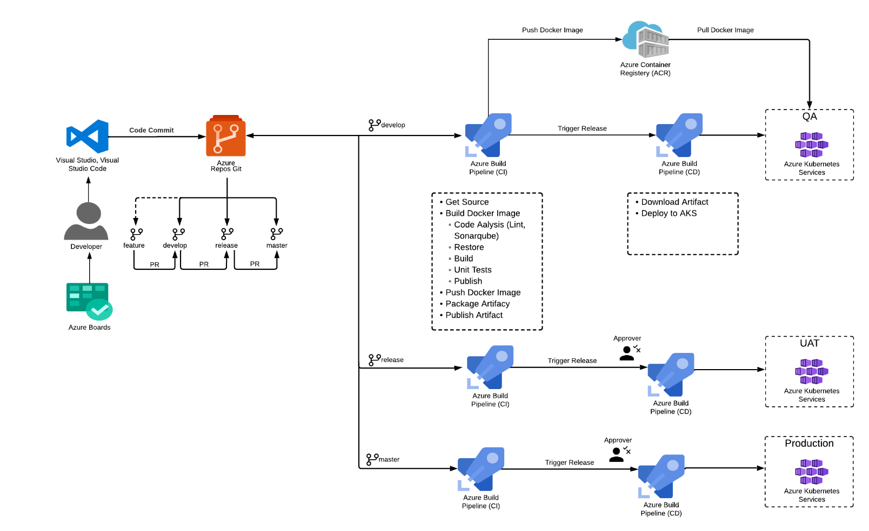
- Azure DevOps build pipeline will be used to build and push docker images to the container repository for QA, UAT and Production release.
- Azure Container Registry will be used to store private Docker images of application components, which will be deployed to the Azure AKS cluster.
- In the release phase, the latest docker images will be fetched from container registry using Kubernetes and will be used to replace the old images with the latest ones. ​
- UAT and Production release will be controlled using approvals, release will only take place once it is approved by defined approvers.
- Once the latest containers are up and running environment, Kubernetes will be used to manage those containers with self-healing, auto scaling and rollback capabilities. Azure Application Insights will be used to collect issues from a specific application release.

